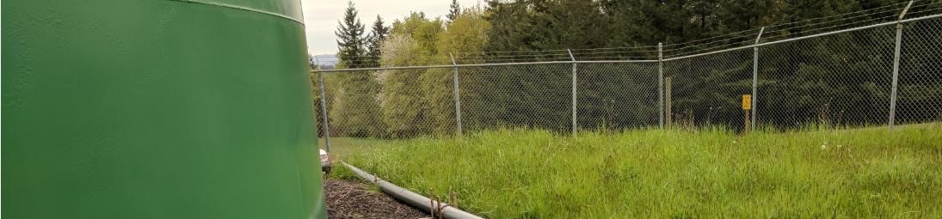

**2021 Annual Drinking Water Report for**

**McNulty Water PUD**

This is the annual Consumer Confidence Report (CCR) for your drinking water system. In this report, you can find general information regarding water quality testing, health information, and specific information regarding the water quality in your water system.

# Educational & Health information

The sources of drinking water (both tap water and bottled water) include rivers, lakes, streams, ponds, reservoirs, springs, and wells. As water travels over the surface of the land or through the ground, it dissolves naturally occurring minerals and, in some cases, radioactive material, and can pick up substances resulting from the presence of animals or from human activity.

Contaminants that may be present in source water include:

* Microbial contaminants, such as viruses and bacteria, which may come from sewage treatment plants, septic systems, agricultural livestock operation, and wildlife.
* Inorganic contaminants, such as salts and metals, which can be naturally occurring or result from urban storm water runoff, industrial or domestic wastewater discharges, oil and gas production, mining, or farming.
* Pesticides and herbicides, which may come from a variety of sources such as agriculture, urban storm water runoff, and residential uses.
* Organic chemical contaminants, including synthetic and volatile organic chemicals, which are byproducts of industrial processes and petroleum production, and can also come from gas stations, urban storm water runoff, and septic systems.
* Radioactive contaminants, which can be naturally occurring or be the result of oil and gas production and mining activities.

Some people may be more vulnerable to contaminants in drinking water than the general population. Immunocompromised persons such as persons with cancer undergoing chemotherapy, persons who have undergone organ transplants, people with HIV/AIDS or other immune system disorders, some elderly, and infants can be particularly at risk from infections. These people should seek advice about drinking water from their health care providers. EPA/CDC guidelines on appropriate means to lessen the risk of infection by Cryptosporidium and other microbial contaminants are available from the Safe Drinking Water Hotline (1-800-426-4791).

To ensure that tap water is safe to drink, EPA prescribes regulations which limit the number of certain contaminants in water provided by public water systems. Food and Drug Administration regulations establish limits for contaminants in bottled water which must provide the same protection for public health.

If present, elevated levels of lead can cause serious health problems, especially for pregnant women and young children. Lead in drinking water is primarily from materials and components associated with service lines and home plumbing. McNulty Water PUD is responsible for providing high quality drinking water but cannot control the variety of materials used in plumbing components. When your water has been sitting for several hours, you can minimize the potential for lead exposure by flushing your tap for 30 seconds to 2 minutes before using water for drinking or cooking. If you are concerned about lead in your water, you may wish to have your water tested. Information on lead in drinking water, testing methods, and steps you can take to minimize exposure is available from the Safe Drinking Water Hotline or at [*www.epa.gov/safewater/lead*.](http://water.epa.gov/drink/info/lead/index.cfm)

# About McNulty Water System and 2021 Sampling Results



**2021 Annual Drinking Water Report for**

**McNulty Water PUD**

**(**

**cont.**

**)**

McNulty PUD contracted with Hiland Water LLC during early 2016 to serve as our field technicians. Hiland provides all our field services as well as emergency on call technicians.

Your drinking water comes from groundwater. We have six wells, five of which obtain water from a deep, confined, layered, volcanic aquifer. One well is shallower and supplementary to the others.

The state of Oregon has completed the assessment plan for our wells, which includes a map of where the water comes from, possible sources of contamination, and a review of the susceptibility of the source for contamination. This plan is available for public review.

We continually sample for many different chemicals and have found little contamination. Contamination is anything other than pure water. We sample total coliform bacteria as an indicator of microorganisms that should not be present. The table below lists all the drinking water contaminants that we detected during the past calendar year or in our most recent test as noted. Drinking water, including bottled water, may reasonably be expected to contain at least small amounts of some contaminants. The presence of contaminants does not necessarily indicate that water poses a health risk. More information about contaminants and potential health effects can be obtained by calling the EPA's Safe Drinking Water Hotline (1-800-426-4791). Below are listed any samples with any detections. For a complete list of tests taken in 2020, please visit <https://yourwater.oregon.gov/chemlatest.php?pwsno=00725>

|  |  |  |  |  |  |  |
| --- | --- | --- | --- | --- | --- | --- |
| Regulated | MCLG | MCL | Our Water | Sample Date | Violation | Typical Source of Contaminant |
| Lead (90th Percentile, ppb) | 0.0 | 15 | 0.003 | June 2021 | No | Corrosion of household plumbing systems; erosion of natural deposits |
| Copper (90th Percentile, ppm) | 1.3 | 1.3 | 0.387 | June 2021 | No | Corrosion of household plumbing systems; erosion of natural deposits |
| Coliform |  | Positive |  | Oct 2021  Nov 2021 |  | Found present at N. Morse Road and Millard Road. Contamination due to leak repair at Millard Rd and N Morse Road Intersection. October and December 2021 |

*This is the most recent monitoring, done in compliance with regulations. **This source has not been in use since Sept 2020.

**Violations**: We had violations in 2021 all relating to the Arsenic in The Aquifer Storage and Recovery (ASR) well that started to produce Arsenic in 2020. Upon discovery, the source was taken off-line. McNulty Water is currently in the final stages of completing the Arsenic Filtration System located at the ASR.

For additional information about McNulty Water PUD, please visit our website at [www.mcnultywater.com](http://www.mcnultywater.com/) or contact us via phone or email. If you would like to attend any of our meetings, please attend one of our board meetings held on the first Tuesday of the month, 7 pm, at the McNulty office, 34240 Millard Rd, Warren, OR, 97053.



**2020 Annual Drinking Water Report for**

**McNulty Water PUD**

**(**

**cont.**

**)**

**McNulty PUD Office Emergencies (Hiland Water)**

Office hours: 9 am to 4 pm M-F Can be reached 24 hours a day

Shannon Tice 503-396-7255 503-554-8333

Phone: 503-397-1301

Email: mcnulty.info@gmail.com